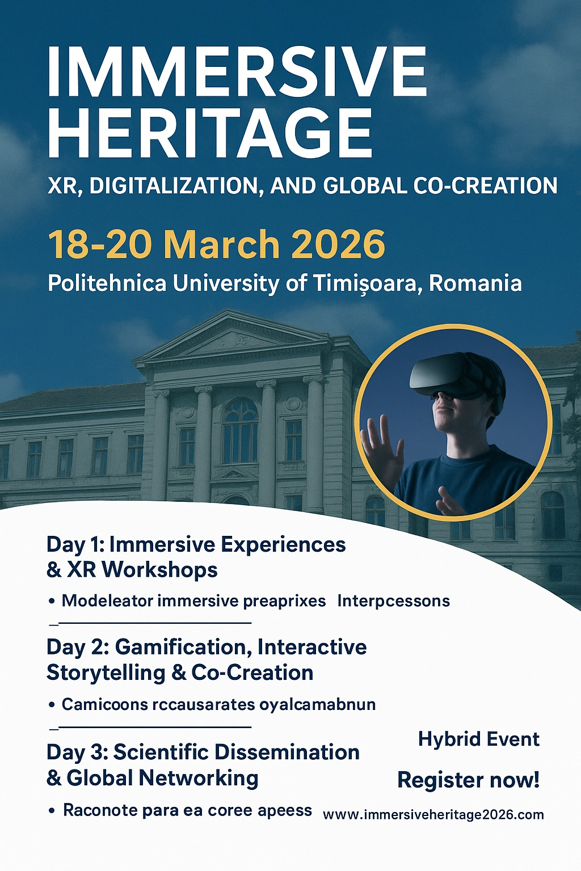
DRAFT PROGRAMME
DAY 1 – Wednesday, 18 March 2026
Theme: Immersive Technologies for Cultural Heritage Preservation
09:00 - 09:45 | Opening Ceremony & Welcome Remarks  - Presentation of the Conference  - Welcome by Rector & Organizing Committee  - Greetings from European partners (Europeana, ICCROM, Creative Europe)
09:45 - 10:30 | Keynote Session  “Immersion as Preservation: XR Technologies in the Service of Heritage”  Speaker: invited speaker
10:30 - 11:00 | Coffee Break & Exhibition Visit
11:00 - 12:30 | Workshop 1: XR for Heritage Reconstruction and Conservation  - Lip3D project  - Add project
12:30 - 14:00 | Guided Tour of the XR Heritage Experience Zone  Public launch of the exhibition area and networking reception
14:00 - 15:30 | Panel Discussion: Bridging Physical and Digital Heritage  3–5 panelists (prof. Manolis Maravelakis)+ 1 moderator (prof. Massimiliano Pepe)
15:30 - 17:00 | Workshop 2: Co-Designing Immersive Narratives  Interactive session on storytelling and user experience design in XR heritage  - Experience on Lip3D (Udanet)

DAY 2 – Thursday, 19 March 2026
Theme: Gamification, Engagement & Cultural Storytelling
09:00 - 09:45 | Keynote Session  “Gamification for Cultural Memory: Engaging New Audiences through Play”  Speaker: invited speaker
10:00 - 11:30 | Panel: Designing Interactive Heritage Experiences  Topics: Serious games, museum interactivity, user-centered design
11:30 – 12:30 | Demo Talks in Exhibition Area  Flash presentations by startups, XR developers, and EU projects
12:30 - 14:00 | Lunch Time
14:00 - 15:30 | Workshop 3: Communicating Cultural Heritage in the Digital Age XR for Heritage Reconstruction and Conservation  Led by communication experts from Creative Europe and museum media labs
15:30 - 17:00 | Roundtable: The Future of Immersive Museums  Discussion between curators, educators, and technology providers
17:00 - 18:30 | Panel Discussion: From Excavation to Digitization – The Archaeological Contribution to Cultural Heritage Innovation  Informal session to connect institutions, research groups, and creative studios

DAY 3 – Friday, 20 March 2026
Theme: Scientific Dissemination, Policy, and Collaboration for Digital Cultural Heritage
09:00 - 09:30 | Welcome & Introduction to the Scientific Track  - Overview of accepted papers and research themes  - Guidelines for hybrid presentations and Q&A
09:30 - 11:00 | Paper Session 1: XR Technologies for Heritage Preservation  Topics include:  - 3D scanning and reconstruction workflows  - Virtual conservation and restoration  Chair: Prof. [Name], Politehnica University of Timișoara
11:00 - 11:15 | Coffee Break
11:15 - 12:45 | Paper Session 2: Integration of digital twins and metadata in heritage documentation  Topics include:  - Architecture  - …………  Chair: Dr. [Name], [Institution]
12:45 – 14:00 | Lunch Time
14:00 - 15:15 | Paper Session 3: Digital Transformation and Cultural Data  Topics include:  - Linked open data, interoperability, and digital archives  - AI and machine learning applications for cultural heritage  - Ethics and sustainability in digital heritage practices  Chair: Dr. [Name], Horizon Europe project representative
15:15 – 15:45 | Roundtable: “Research Meets Policy”  Dialogue between researchers, European funding agencies, and policy representatives  - Aligning research priorities with EU cultural innovation agendas  - Building cross-sector collaborations and knowledge transfer
15:45 – 16:15 | Best Paper & Poster Awards Ceremony  Recognition of outstanding contributions in scientific dissemination and innovation
16:15 – 17:00 | Closing Remarks & Future Outlook  - Summary of main outcomes from the conference and exhibition  - Announcement of Immersive Heritage 2027  - Group photo & Farewell Reception

From 18 to 20 March 2026
Theme: Immersive Heritage Exhibition Area
Parallel Activity
09:00 – 17:00 | Main Hall - Politehnica University of Timișoara  - XR/VR/AR heritage experiences  - Interactive installations and digital artifacts  - 3D scanning & digitization demos  - International booths (universities, museums, startups, EU projects)

Committee scientific
Sorin Herban
Massimiliano Pepe
Vincenzo Saverio Alfio
Oliva Menozzi
Donato Palumbo
Domenica Costantino
Andrei Crisan
Emmanuel Maravelakis
Kristoff Narlock
Sylvie Trullet
Mauro Lo Brutto
Athanassios Mailis
Przemysław Klapa

Local Commission
……..
……..
……..
……..
……..
……..

Invitation Company
Holofiction
CyNexo
Ud’Anet
Muzeul Civilizatiei Dacice si Romane Deva
People in Focus

